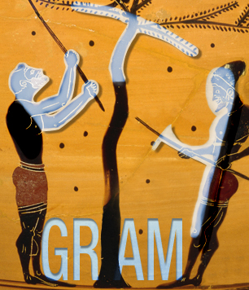
Bulletin of membership

in the ETYGRAM Association
« ETYmologies GRecques Antiques & Médiévales »

« Ancient & Medieval Greek Etymologies Association »

The present bulletin of membership is to be sent back completed to assoc.etygram@gmail.com. as an attachment to an electronic message.

The purposes of the association are (Art. 2 of the Statutes of ETYGRAM):
• to promote the study of ancient Greek and Byzantine texts dealing with etymology-related issues on the Greek language and ancient Greek semantics, and to disseminate the results of that research;
• to produce an online dictionary of ancient and medieval Greek etymologies through collaborative work and to develop other free-access electronic tools on ancient and medieval Greek etymology ;
• to encourage any undertaking linking research and educational activities on investigating the words of the Greek language as a creative operation, both scholarly and playful.

The subscription is 30€, and may be sent by bank transfer (see RIB/IBAN) or cheque to the « Association ETYGRAM », by stating your exact name to the following address: ETYGRAM. c/Richard Faure. BCL. Université Nice Sophia Antipolis. MSHS Sud-Est. 24, avenue des Diables Bleus, 06357 Nice Cedex 4. Please specify if you need a receipt.

Year
Name
Surname
Address
Additional address (optional)
Postal Code and city
Telephone
E-mail
Title/Position
Research Centre
University/ Institution/ School, etc.
Research fields, work/project in progress, participation in collective enterprises (in relation to the purposes of the Association)
Web page

